mRemedy

Training Document
Index
- Document Overview
  - Purpose of the Document
  - Scope of the Document

- Product Overview
  - About www.mremedy.com
  - About www.mremedy.com/admin/
  - About www.wap.mremedy.com

- Consumer Site – Functionality
  - Home
  - About us
  - Products
  - Support
  - Contact us
  - Login
  - Terms of use
  - Privacy policy

- Admin - Functionality
  - Login
  - Metrics
  - Hospital
  - App settings
  - App builder
  - User
    - Admin User
    - Hospital User
    - Salesperson User
    - Company User
  - Article
  - Account

- WAP – Functionality
  - Physicians
  - View Locations
  - Contact us
  - Medical Library
    - Diseases & Conditions
    - Tests & Procedures
    - Health Tips
  - First Aid
  - Latest News
  - Floor Plans

1. Document OVerview

1.1 Purpose of thE document
The purpose of this document is to:
    - Shows a detail view of what the software is supposed to do.
    - Expounds how things work from users and admin perspective.

1.2 scope of thE document
This document covers and expounds the already approved functionality of mRemedy site developed for the users to know about hospital information like physicians list, contact information, hospital floor plans, test procedures, diseases and its symptoms and the information that is need from the backend.

2. Product Overview
2.1 About mremedy.com
www.mremedy.com is the general website which let the users to know about the latest products release & the latest articles published in the site, also the users can avail support for the products introduced and they can contact if they have question about the site or mRemedy's products or services.
Users can login to the site by using the email id, password used in the app. Logged in users can download the CSV of their own trackers say for e.g. myWeight, myPressure etc...
2.2 About mremedy.com/admin/
www.mremedy.com/admin/ - The admin part is for the site administrators to login and maintain database for hospitals, physicians list, posting latest article, maintain different level of users & also view the user activities & iPhone, Android downloads statistics.
2.3 About wap.mremedy.coM
www.wap.mremedy.com – mRemedy wap is for the users who were not installed the app in their phones can access via browsers. They can access medical library, physicians list, latest article, floor plans. Wap users are restricted to access Health trackers as it is accessible only to app users.

3 Consumer Site – Functionality
3.1 home

Home page contains the latest news displayed at the bottom of the page, clicking all articles will lead to the article list page as below. Article section displayed here is maintained from admin.

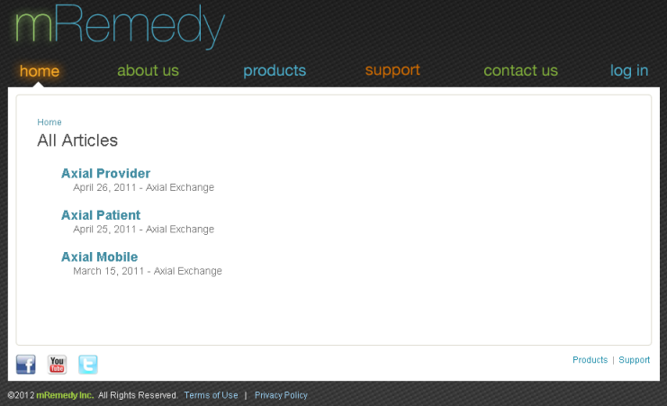

3.2 about us
About us contains short summary about the Management team, Board of directors and Advisory team as shown below screenshot.
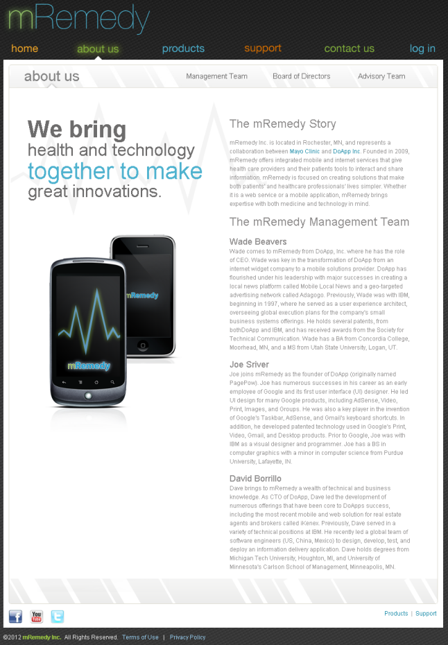
3.3 PRODUCTS

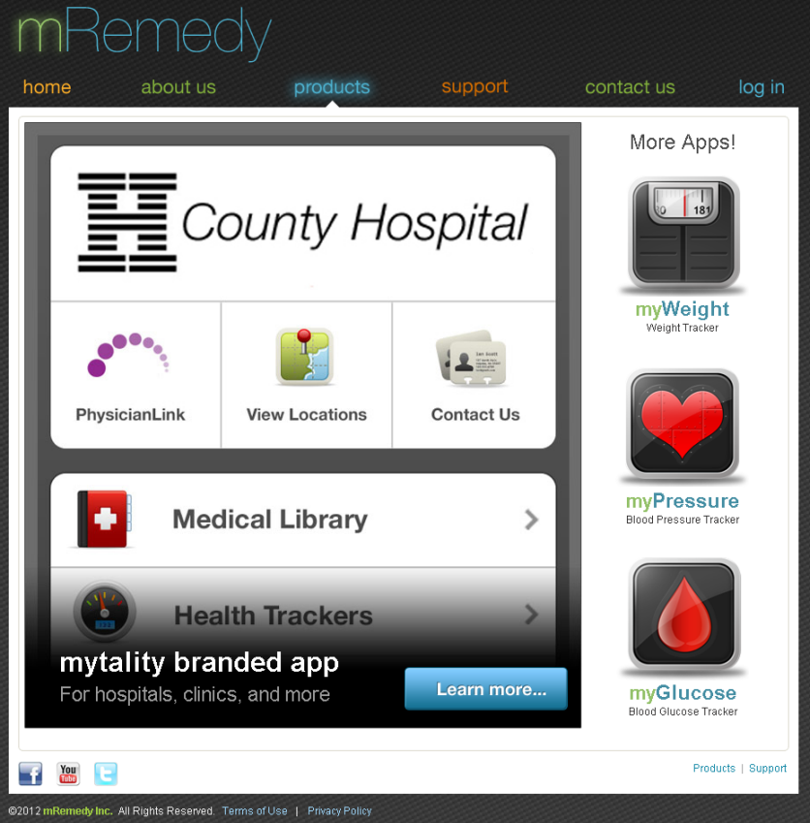

Products page will display the latest products on the right side, clicking on the each tracker will leads to the product detail description with download option as shown in below screenshot. Users can download the app via iTunes store.
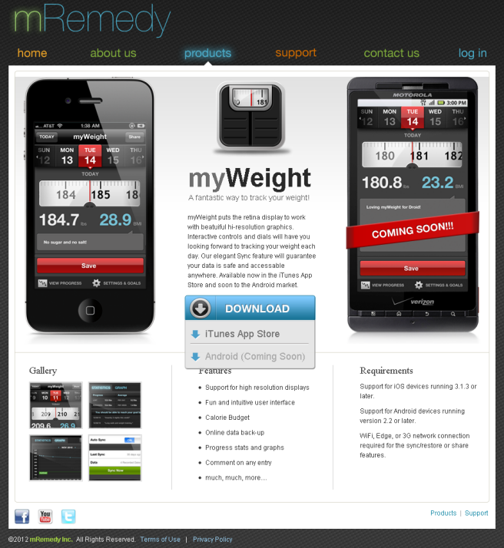

3.4 SUPPORT

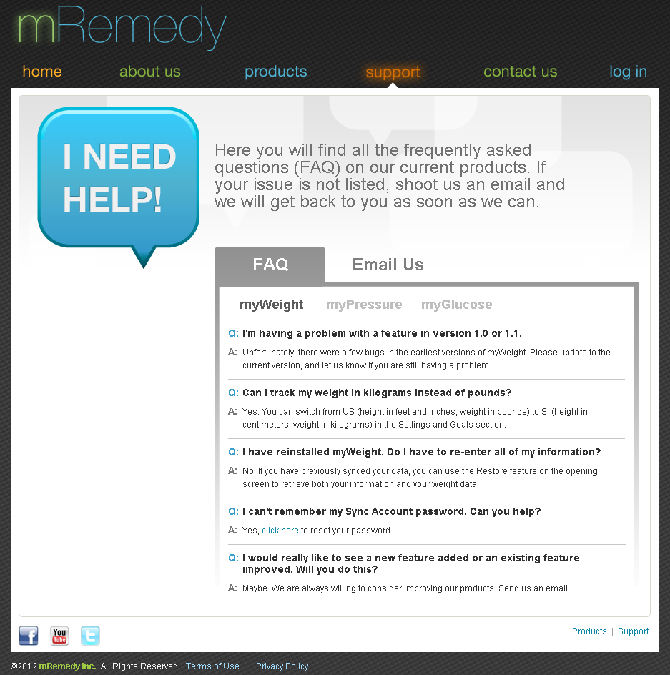
Users can see the FAQ for various queries posted here also they can send email for their queries if it is not listed in FAQ. Refer screenshot below.

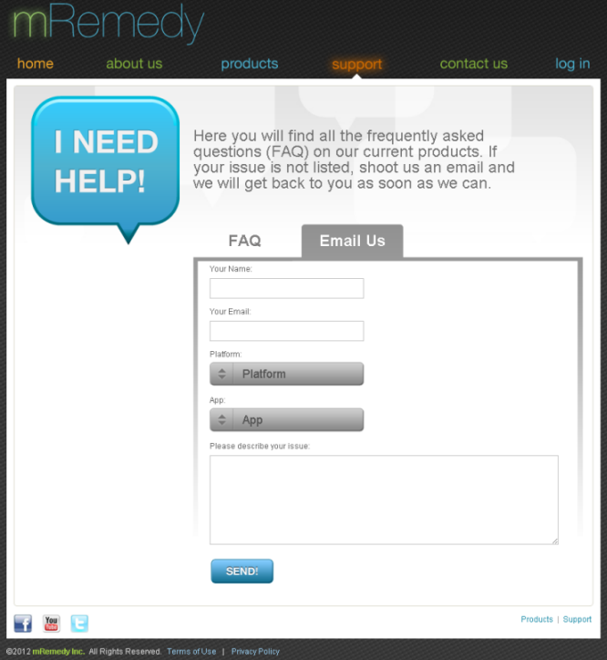
Users can send email stating the issue & they can choose platform & app name for detail information.

3.5 CONTACT US

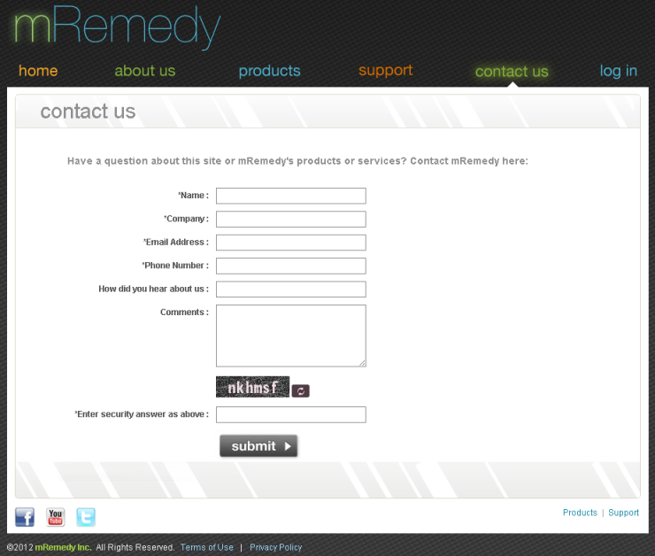
Users can also contact via contact us page if they have questions about the site or mRemedy products or services.

3.6 LOGIN
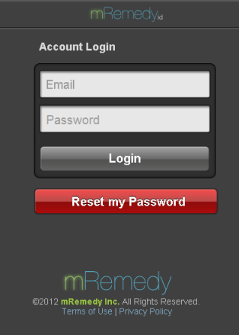
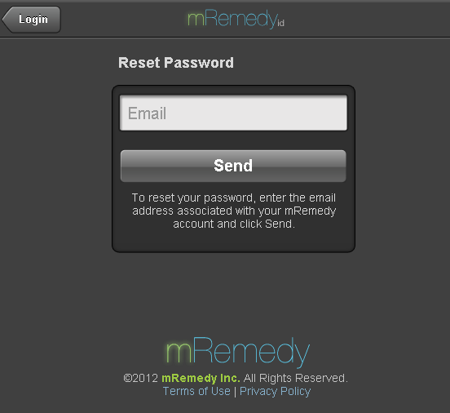
Users can login to the site by using the email id, password used in the app also they can reset the password if it is forgotten.

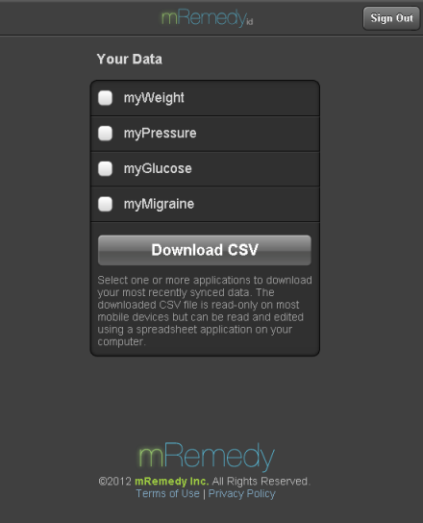
Logged in users can download the CSV of their own trackers say for e.g. myWeight, myPressure etc...

3.7 TERMS OF USE
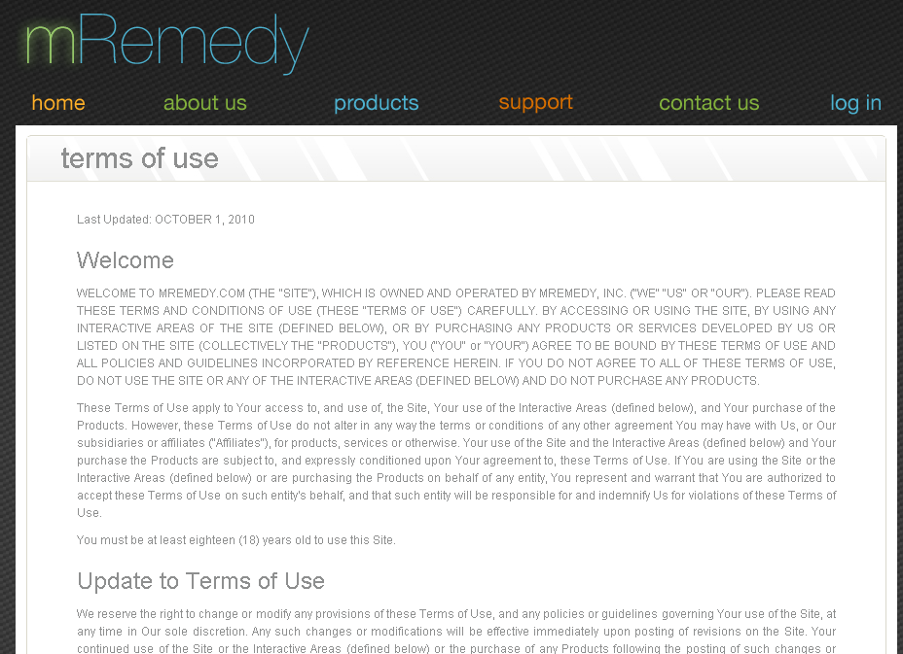

3.8 PRIVACY POLICY
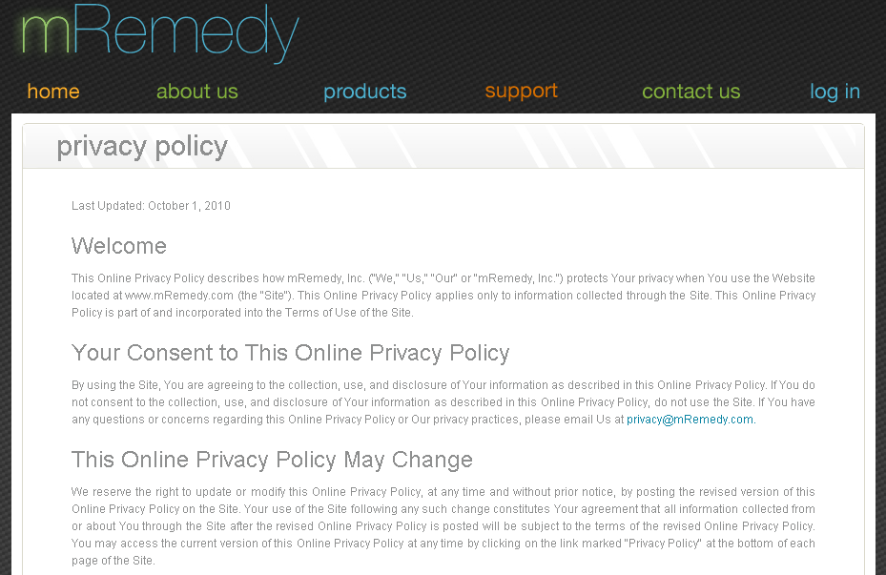
Users can read the privacy policy & terms of use from the corresponding pages.

